EXPT NO: 6 | IMPLEMENTATION OF LSTM FOR SENTIMENT ANALYSIS
DATE: 30.10.2026 | IMPLEMENTATION OF LSTM FOR SENTIMENT ANALYSIS

PRE-LAB QUESTIONS (PROVIDE BRIEF ANSWERS TO THE FOLLOWING QUESTIONS)

- Purpose of LSTM in NLP:
LSTM networks process sequential text data while remembering important long-term information. They overcome the vanishing gradient problem, making them effective for language modeling, translation, text generation, and sentiment analysis.
- Why is LSTM preferred over a Simple RNN?
LSTMs use memory cells and gates to retain relevant information over long sequences. Unlike Simple RNNs, they avoid vanishing gradients and better capture long-term dependencies in text.
- What is sentiment analysis? Give two applications.
Sentiment analysis identifies emotions or opinions in text as positive, negative, or neutral. Applications include analyzing customer reviews for products and monitoring public opinion on social media.
- Role of tokenization and padding in text preprocessing:
Tokenization splits text into words or subwords for model processing. Padding adds extra tokens to make all sequences equal length, enabling efficient batch training in neural networks.
- What is word embedding? Why is it useful?
Word embedding converts words into dense numerical vectors representing semantic meaning. It helps sentiment analysis by capturing word relationships, improving context understanding, and enhancing classification accuracy over one-hot encoding
AIM
To implement a Long Short-Term Memory (LSTM) network for sentiment analysis by performing text preprocessing, tokenization, sequence generation, and embedding using NLP libraries, and classify text into sentiment categories.

SOFTWARE REQUIREMENTS
- Python
- TensorFlow / Keras
- Google Colab
- GitHub
- NumPy
- Pandas
- Matplotlib
- NLP libraries – NLTK / spaCy
- Scikit-learn

OBJECTIVES
Students will be able to:
- Understand the architecture and working of LSTM networks.
- Perform text preprocessing techniques for sentiment analysis.
- Tokenize and convert textual data into numerical sequences.
- Generate word embeddings for textual data.
- Build and train an LSTM model for sentiment classification.
- Evaluate the performance of the trained LSTM model.
- Analyze the effect of preprocessing and embedding on sentiment classification.

PROCEDURE
PART A: DATASET PREPARATION AND TEXT PREPROCESSING
- Perform the following tasks:
- Load a sentiment analysis dataset such as the IMDB Movie Reviews dataset.
- Explore the dataset and examine sample positive and negative reviews.
- Check the number of samples and sentiment class distribution.
- Perform text preprocessing using NLP libraries.
- Convert text to lowercase.
- Remove unnecessary punctuation and special characters.
- Remove stop words, if required.
- Tokenize the reviews into words/tokens.
- Convert the tokens into numerical sequences using a tokenizer.
- Build a vocabulary from the training reviews.
- Apply sequence padding to obtain equal-length input sequences.
- Encode sentiment labels into numerical form.
- Split the prepared dataset into training and testing/validation datasets.
(CODE: CONATAINS STUDENT ROLL NOS
SCREENSHOT OF CODE
SCREENSHOT OF OUTPUT)

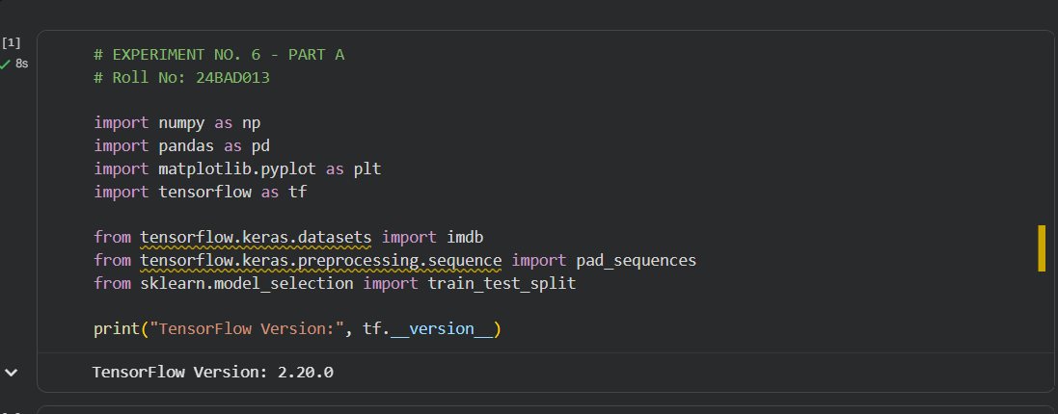

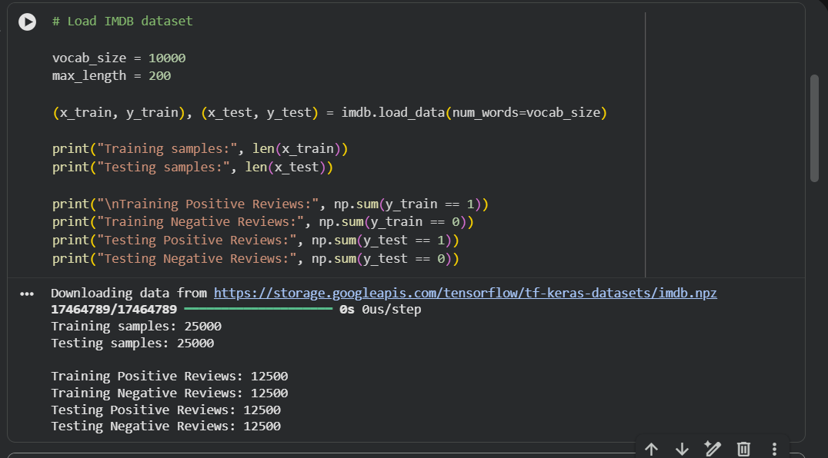
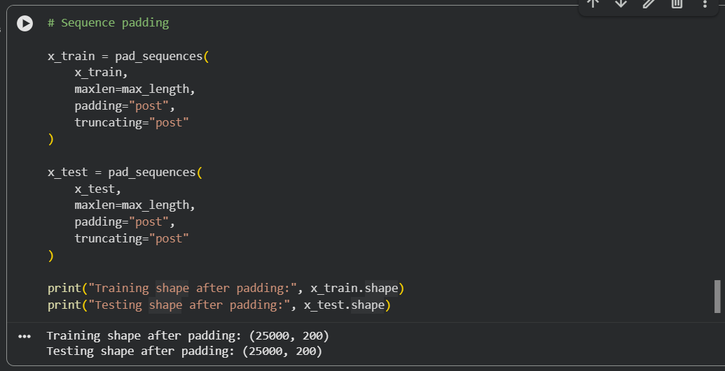
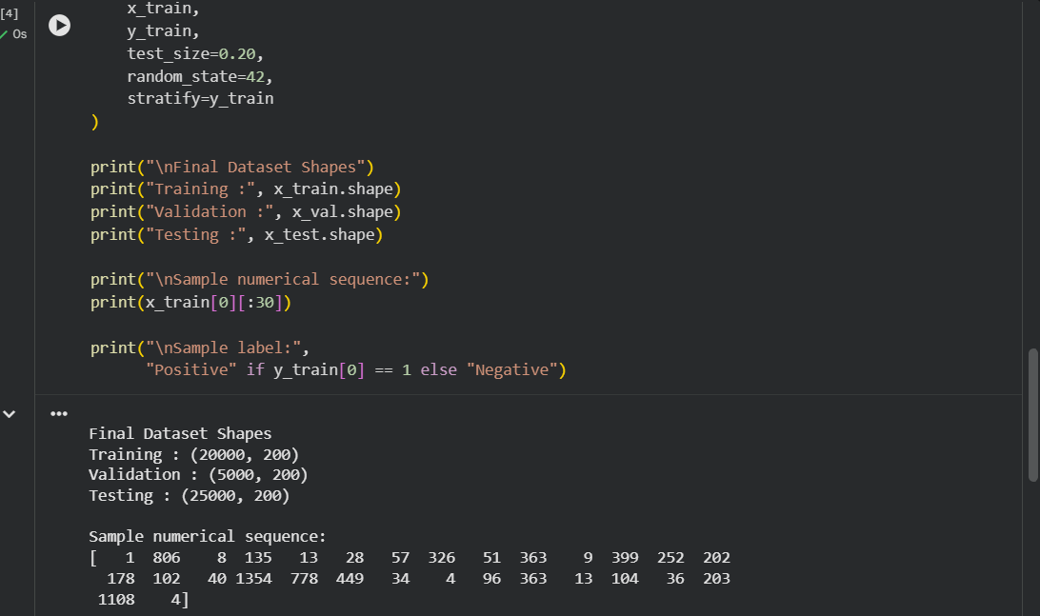

PART B: EMBEDDING GENERATION
Perform the following tasks:
- Generate numerical representations of the pre-processed text.
- Create an Embedding layer using Keras/TensorFlow.
- Define the vocabulary size and embedding dimension.
- Convert tokenized sequences into dense vector representations.
- Display the shape of the generated embedding representation.
- Analyze how words are represented in the embedding space.
(CODE: CONATAINS STUDENT ROLL NOS
SCREENSHOT OF CODE
SCREENSHOT OF OUTPUT)

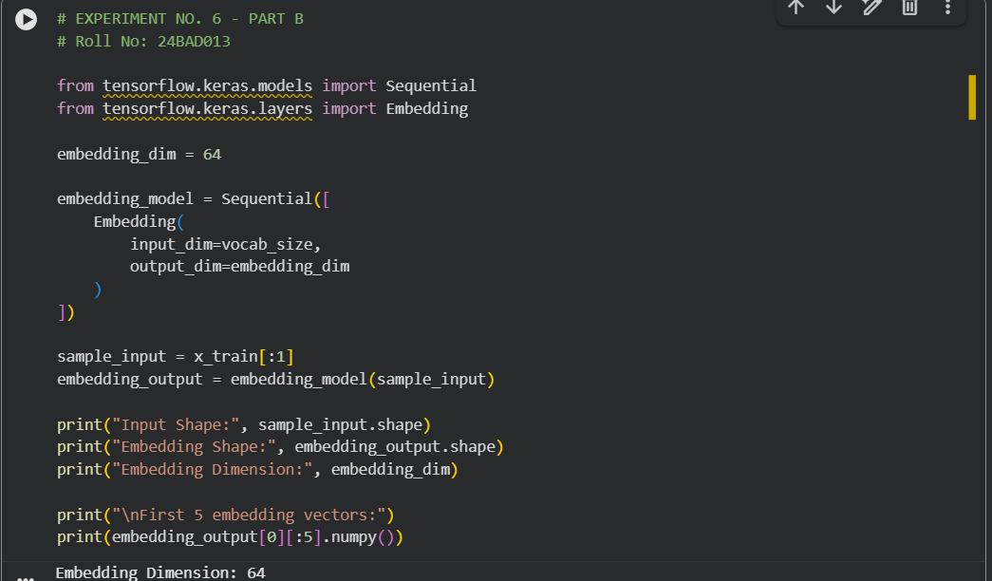
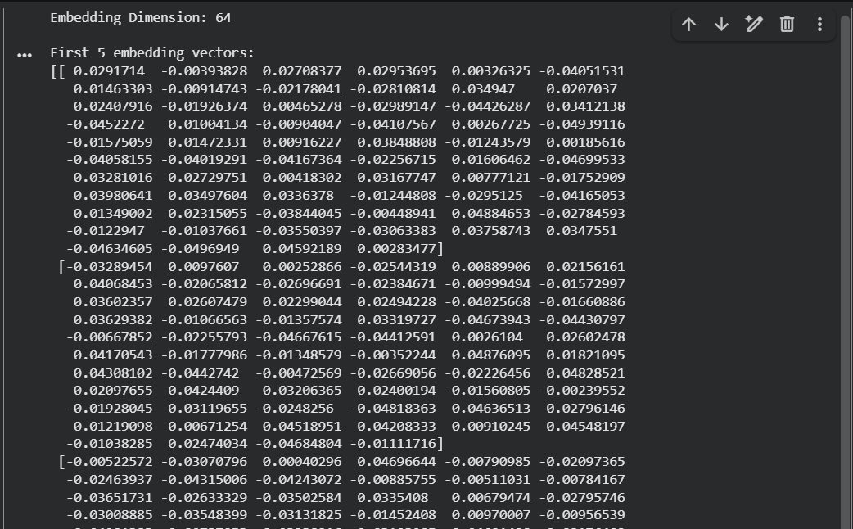
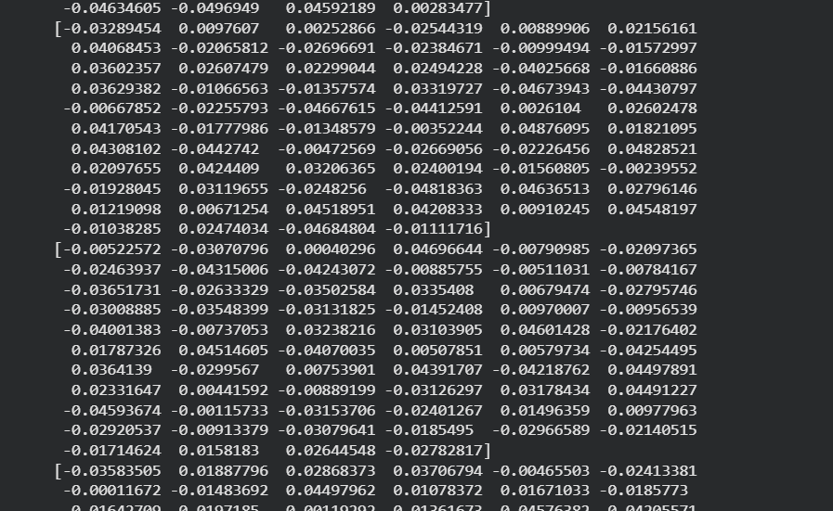

PART C: IMPLEMENTING THE LSTM MODEL
Perform the following tasks:
- Create an input layer for the padded text sequences.
- Add an Embedding layer to generate dense word representations.
- Add an LSTM layer to learn sequential dependencies in the reviews.
- Add a Dense output layer with an appropriate activation function for sentiment classification.
- Compile the model using:
  - Appropriate optimizer
  - Binary cross-entropy loss
  - Accuracy as the evaluation metric
- Display the model architecture and summary.
(CODE: CONATAINS STUDENT ROLL NOS
SCREENSHOT OF CODE
SCREENSHOT OF OUTPUT)

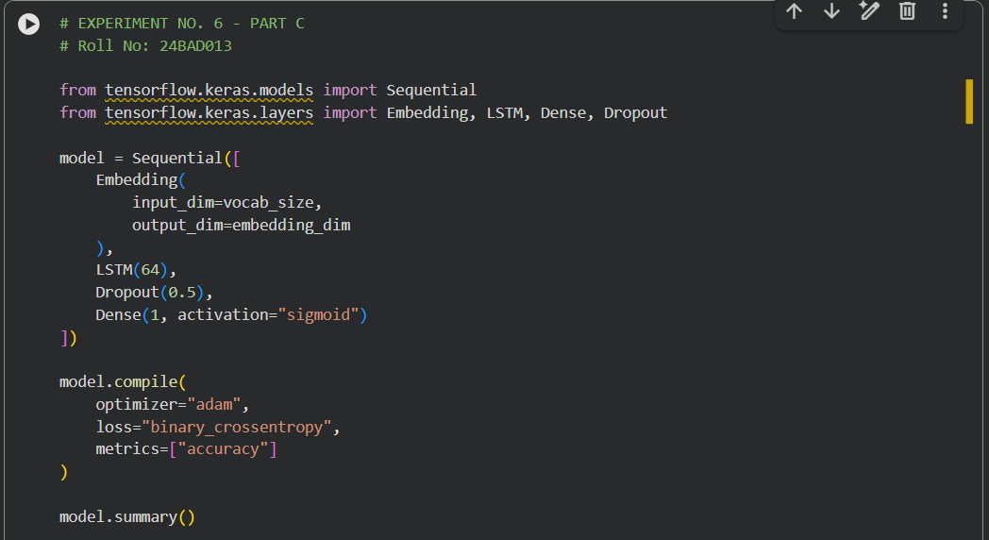
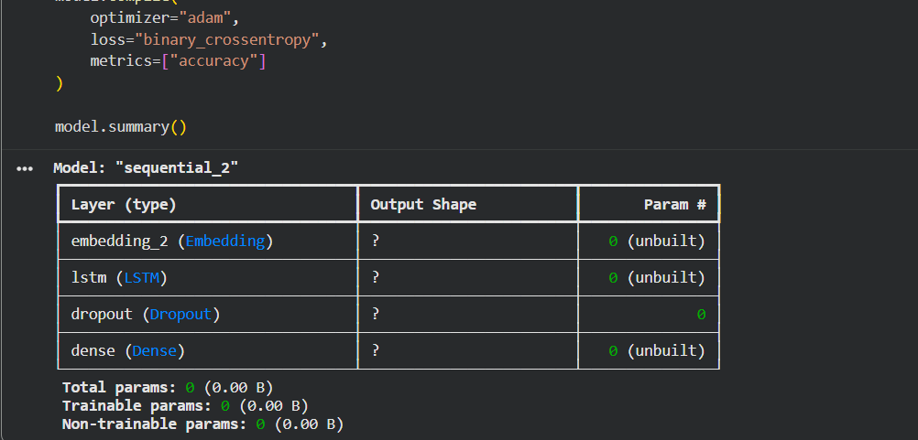

PART D: MODEL TRAINING AND SENTIMENT PREDICTION
Perform the following tasks:
- Train the LSTM model using the prepared training dataset.
- Validate the model using the validation dataset.
- Record:
  - Training accuracy
  - Validation accuracy
  - Training loss
  - Validation loss
- Visualize:
  - Accuracy vs. Epoch
  - Loss vs. Epoch
- Evaluate the trained model using the test dataset.
- Predict the sentiment of sample reviews.
- Compare the predicted sentiment with the actual sentiment.
- Calculate appropriate evaluation metrics such as:
  - Accuracy
  - Precision
  - Recall
  - F1-score
  - Confusion matrix
(CODE: CONATAINS STUDENT ROLL NOS
SCREENSHOT OF CODE
SCREENSHOT OF OUTPUT)

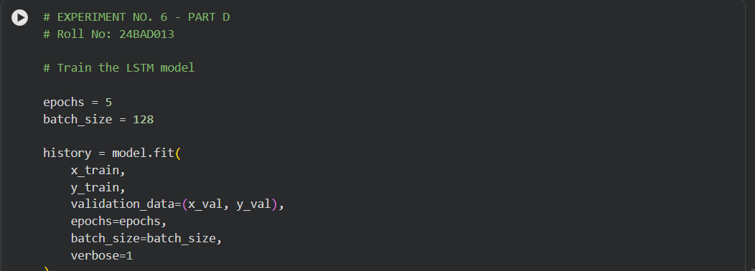
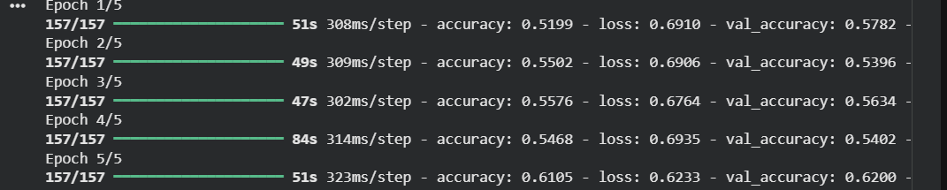
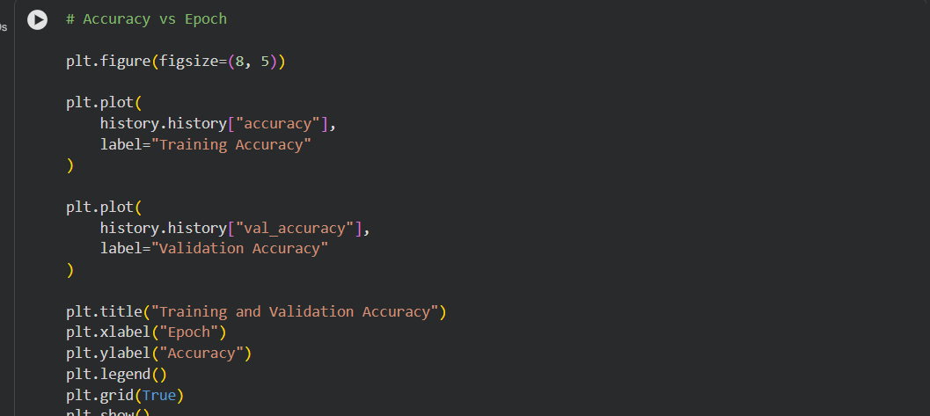
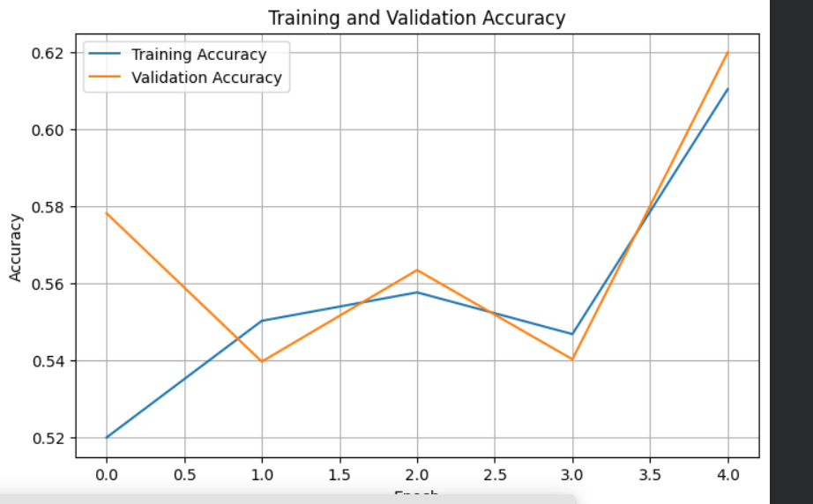
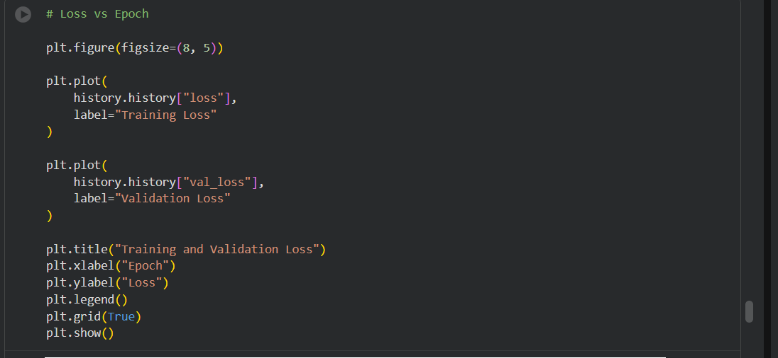
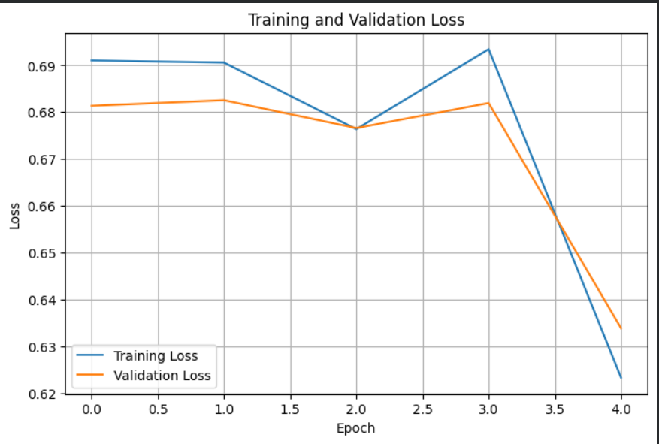
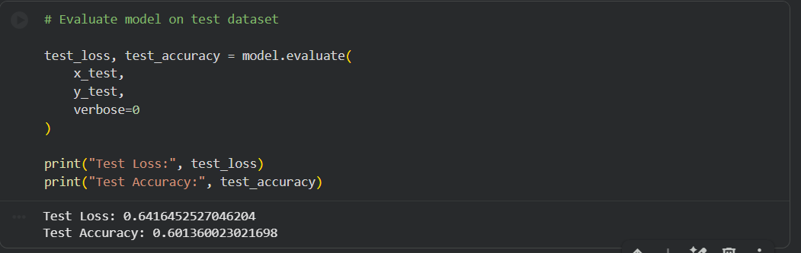
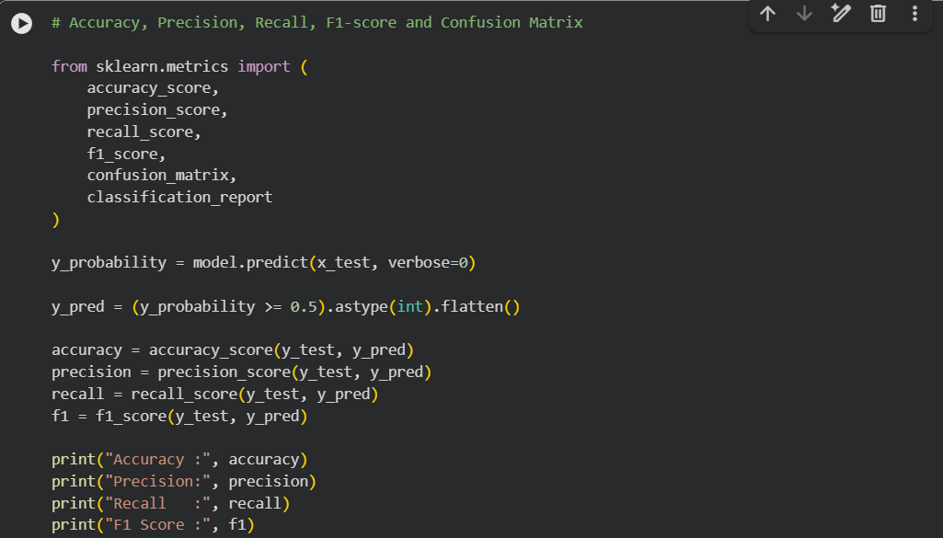
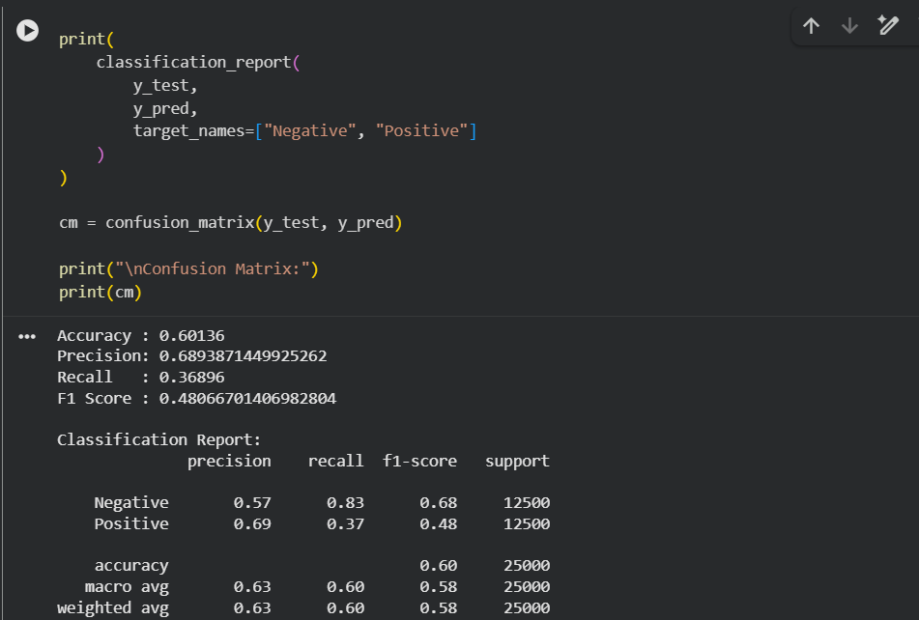
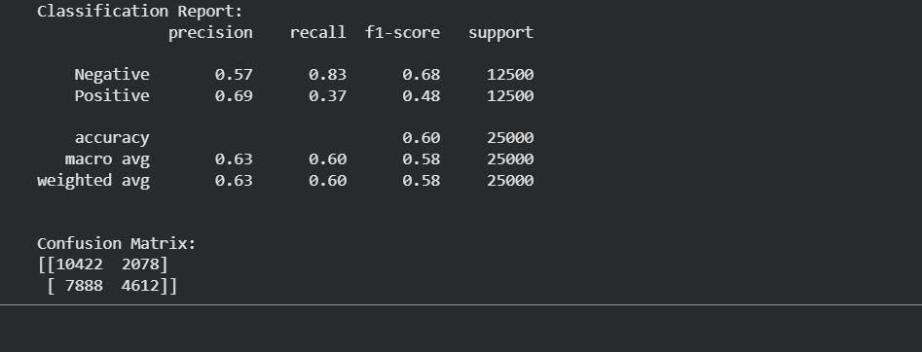

EXPECTED OUTCOME
Students will understand how LSTM networks learn sequential information from textual data and apply them to sentiment classification. Students will learn to perform text preprocessing, tokenization, sequence padding, and embedding generation using NLP libraries. They will build and train an LSTM model and evaluate its ability to classify reviews into positive and negative sentiments.

POST-LAB QUESTIONS (PROVIDE BRIEF ANSWERS TO THE FOLLOWING QUESTIONS)
- Role of the memory cell in an LSTM:
The memory cell stores important information over long sequences. It selectively keeps, updates, or removes data using gates, helping the network learn long-term dependencies in text.
- How does LSTM overcome the vanishing gradient problem?
LSTM uses input, forget, and output gates with a memory cell to preserve information. This controlled flow enables gradients to pass through long sequences without rapidly vanishing.
- Purpose of the Embedding layer:
The Embedding layer converts words into dense numerical vectors that capture semantic relationships. It reduces dimensionality and helps the LSTM understand word meanings and contextual similarities.
- How does padding affect LSTM input?
Padding adds extra tokens to shorter sequences, making all inputs equal length. This allows efficient batch processing while preserving the original sequence order for the LSTM.
- What happens when training for too many epochs?
Training for excessive epochs may cause overfitting. The model memorizes training data, reducing its ability to generalize and resulting in poorer performance on unseen test data.
- Why are precision, recall, and F1-score useful?
Precision measures prediction accuracy, recall measures detection of actual positives, and F1-score balances both. They provide better evaluation than accuracy, especially for imbalanced datasets.
- One limitation of using LSTM for sentiment analysis:
LSTMs require high computational resources and long training times. They may also struggle with very long documents and often need large labeled datasets for good performance.

SUGGESTIONS FOR DATASETS
- IMDB Movie Reviews – https://ai.stanford.edu/~amaas/data/sentiment/
- SST-2 (Stanford Sentiment Treebank) – https://huggingface.co/datasets/stanfordnlp/sst2
- Twitter Sentiment Analysis – https://www.kaggle.com/c/twitter-sentiment-analysis
- Stanford Sentiment Treebank (SST) – https://huggingface.co/datasets/stanfordnlp/sst
- Amazon Product Reviews – https://huggingface.co/datasets/amazon_polarity
- Yelp Polarity Reviews – https://huggingface.co/datasets/fancyzhx/yelp_polarity

ASSESSMENT
Description | Max Marks | Marks Awarded
Pre Lab Exercise | 5
In Lab Exercise | 10
Post Lab Exercise | 5
Viva | 10
Total | 30
Faculty Signature

